Honeycomb Torus Network of dimension two $HCT(2)$

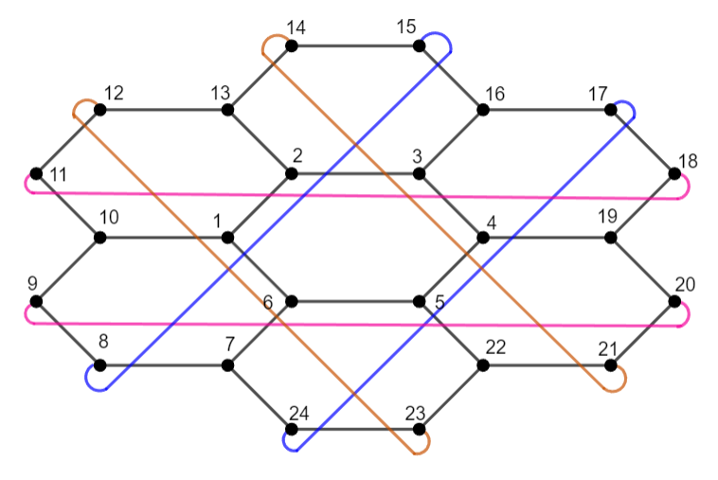

1-fault tolerant metric dimension - 6

$1DRW$ Index – 28

Extracted 1-fault tolerant metric bases using extended $BIGS$ algorithm

1. {1, 3, 5, 8, 14, 20}
2. {1, 3, 5, 12, 18, 24}
3. {1, 4, 7, 9, 16, 18}
4. {1, 4, 8, 12, 17, 21}
5. {1, 4, 11, 13, 20, 22}
6. {1, 7, 9, 12, 14, 22}
7. {1, 8, 11, 13, 16, 24}
8. {2, 4, 6, 9, 15, 21}
9. {2, 4, 6, 11, 17, 23}
10. {2, 5, 7, 14, 16, 23}
11. {2, 5, 10, 12, 19, 21}
12. {2, 5, 11, 15, 20, 24}
13. {2, 7, 10, 12, 15, 17}
14. {2, 9, 11, 14, 16, 19}
15. {3, 6, 8, 10, 17, 19}
16. {3, 6, 9, 14, 18, 23}
17. {3, 6, 13, 15, 22, 24}
18. {3, 10, 13, 15, 18, 20}
19. {3, 12, 14, 17, 19, 22}
20. {4, 7, 15, 17, 20, 22}
21. {4, 13, 16, 18, 21, 23}
22. {5, 7, 10, 18, 20, 23}
23. {5, 8, 16, 19, 21, 24}
24. {6, 8, 10, 13, 21, 23}
25. {6, 9, 11, 19, 22, 24}
26. {7, 10, 13, 16, 19, 22}
27. {8, 11, 14, 17, 20, 23}
28. {9, 12, 15, 18, 21, 24}